Project Proposal
Systems Design and Development
Rachael Slack, Matthew Dwane, Mason Hall, Constantinos Nicolaou
Contents
- Background
- The Brief
- Technology
- Designing Process
- Requirements
  - Functional
  - Non-Functional
- Timeline for the Project
- Other Ideas
- Use Cases
  - Diagram
  - Descriptions

Background
There has been a lot of major changes for everyone in the stream of their normal lives. Where people used to be able to sit around a table and play their favourite games with each other, this is now being done online over video calling software.
One game in particular that we have decided to focus on is Dungeons & Dragons (What Is D&D?, n.d.). This is a game that is very traditionally played as a tabletop role playing game, with a Dungeon Master (DM) and players who act as characters within this narrative based game. A lot of the resources are paper based, with many books and physical die creating the large arsenal of information available to both the dungeon masters and the players out there who are involved.
When considering that this is now being moved online due to circumstances outside of everyone’s control, there is a lot that is missing in terms of a singular Dungeons & Dragons arsenal to help manage campaigns. There is often a need to have multiple tabs open of web applications, text documents, photos, and maps all at once, as well as still having physical things such as paper and pen for a session of the campaign.
There are applications out there that have started to compile some of these sources (D&D Beyond, n.d.) however they are often still in early stages of builds for some features, and the majority of content is locked behind pay walls, where the books themselves are accompaniments to the website. They also allow for ‘home brew’ content, which is content made up by the players themselves, that is not officially linked to the game.
There are websites out there that do allow for a slightly more relaxed approach on the information with websites like Roll20.net (Roll20: Online Virtual Tabletop, n.d.) having an open library of information, as well as ways to join strangers’ campaigns, but this is open to many more different kinds of role-playing tabletop games, and not just dungeons & dragons.
A lot of the information can sometimes be difficult to digest, especially as someone who is new to the game, and having a handy guide within the application that is easy to navigate to is usually open on another tab, or a link shared to a group chat, or just simply being read out loud from the screen/book.
The Brief
The application that we are looking to build will be designed to help a dungeon master run a campaign smoother, and for players to be able to access information and store their character sheets in a place that is more secure that the folded piece of paper in a bag. The application will ideally be a web application, with the ability to create accounts on both the dungeon master’s part and the players part, creating and joining campaigns, and looking up the information related to that.
The application should be easy to navigate as a beginner to the game, as well as veterans who have played for years. Information will be locked behind an account; however, this is not a paid for account, and to manage who has access to campaigns.
As a group, the hope is that there is an open-source API that the information from the base game can be taken from and used to populate the application this way. With this, it is hoped that players and dungeon masters will be able to look up the information for weapons, spells, items, magical items, and much more.

Technology
Ideally the application will be built as an MVC .NET application, using an entity framework for the database, written in C# as the back-end development, and with the front-end using JavaScript (possibly pushing into the React (React – A JavaScript Library for Building User Interfaces, n.d.) framework) with HTML and CSS as standard.
Designing Process

The designing process for this application will include creating diagrams for the way that the application will flow. The ideal plan would be to have a class diagram, use case diagram and use case descriptors before starting to create any of the code to help guide the work.

Requirements
Below are the functional and non-functional requirements that the application has:
Functional Requirement
- The user will be able to create an account.
- The user will be able to log into their account.
- The user will be able to create new campaigns.
- The user will be able to join existing campaigns of others.
- The user will be able to access basic guidance for campaign running.
- The user will be able to access separate campaign “dashboards”
- The user will be able to look up and select spells.
- The user will be able to sort spells via class.
- The user will be able to look up and select monsters/bosses.
- The user will be able to look up and select items.
- The user will be able to use a dice roller built into the application.
- The user will be able to see a set of previous dice rolls within a set limit.
- The user will be able to write up campaign notes for planning purposes.
- The user will be able to store world-building materials with text (things such as images or map, character pictures).
- The user will be able to pre-plan encounters with mobs.
- The user will be able to manage initiative order within the application and “encounter view”.
- The user will be able to manage damaging tracking for the mobs.
- The user will be able to write up session notes.
- The user will be able to store character sheets within the application.
- The user will be able to track saving throws for the player characters.
- The user will be able to share campaign updates.

Non-Functional Requirements
- The application should be available 95% of the time.
- Any sort of maintenance should be planned and advertised so.
- The application should be accessible to at least level A WCAG2.1. (Web Content Accessibility Guidelines (WCAG) 2.1, 2018).

Timeline for the project

From the time that the proposal goes in, there will be just over 2 months to get the project up and running, as well as getting the application to its minimum viable product status.

Below can be seen the rough timeline of when we, as a team, expect things to be done by:

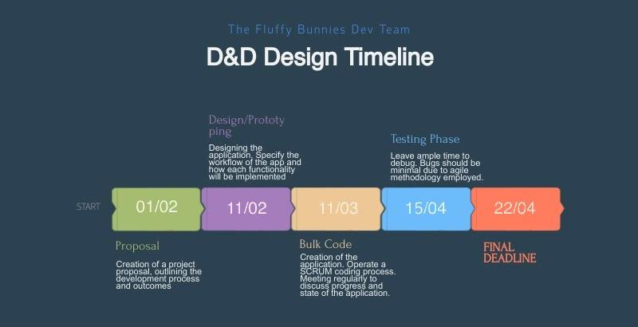

Ideally within the prototyping phase, a draft of the application will be created, with diagrams and drafts to demonstrate the functionality of how the application will work. Once this has been done, we can then move onto the bulk code phase of the project, operating under a scrum structure, using 1-week sprints for coding to make sure that things stay on track.
Workload and communication will be managed via discord, with a server having already been set up. On top of this, code will be managed via GitHub, as the branching functionality means that there will be less chance that code gets over-written by another member of the team, and pull requests mean that code can be checked by a member of the team to make sure that we are happy with how it is being implemented.
At this point, the team is split into the product owner (Mason), Scrum Master (Rachael), with the development and design being done by everyone (Mason, Rachael, Costas, Matt). Testing will be written as the code is being done and will also be carried out by everyone in the team, as we are not working in a large enough group for this to be split equally and within the given time frame.

Other Ideas
The specifics of what extensions could realistically be implemented have not been fully decided upon and remain out of the scope of this proposal, however, some of the considered alternatives follow.
- A client-side desktop application using WPF or Java
- The addition of APIs to allow for the integration of different apps
- A mobile application using C# or java.
- A focus on front end development with the aim to create a more advanced UI with reactive features using JavaScript or react.

Use Cases
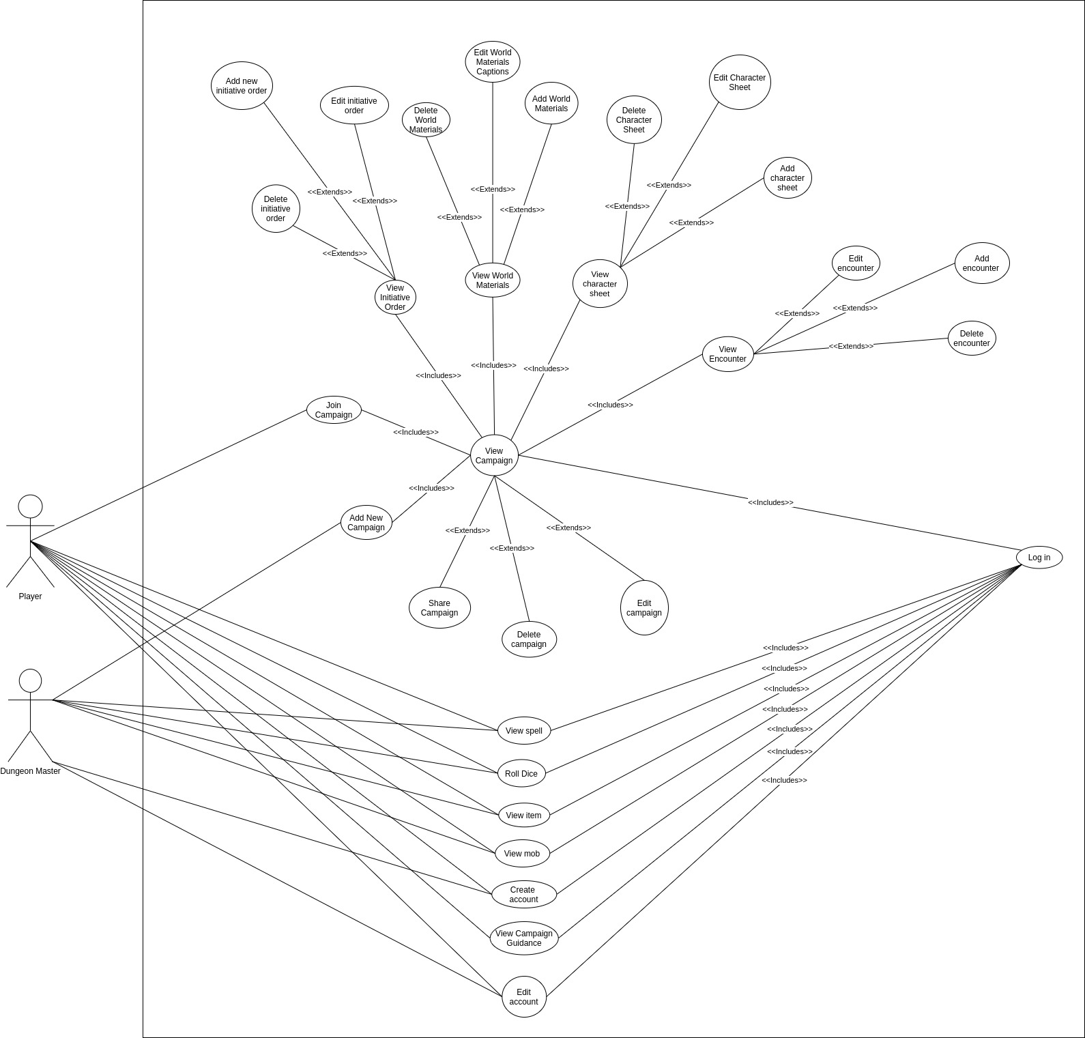
Below can be seen the use case diagram for the application:

Use Case Descriptions
A list of the available use case descriptions can be seen below:
- Create account
- Log in
- Edit account
- Join campaign
- Add new campaign
- View Campaign
- Share Campaign
- Edit Campaign
- Delete Campaign
- View Initiative Order
- Add new initiative order
- Edit initiative order
- Delete initiative order
- View world materials
- Add world materials
- Edit world materials caption
- Delete world materials
- View Character Sheet
- Add Character Sheet
- Delete Character Sheet
- Edit character sheet
- View encounter
- Edit encounter
- Add encounter
- Delete encounter
- View spell
- View item
- View MOB
- View campaign guidance
- Roll dice

Create account
Name: Create Account
Description: Allows the user to create an account on the application.
Actors:
- DMs
- Players
Preconditions: The user has navigated to the application.
Basic Course:
- The user selects create account
- The user enters the required information.
- The user selects submit
- The system validates the information.
- The system redirects the user to the login page.
Alternate Course:
- 4.1 The information is not valid in the system.
- 4.2 The system displays an error message.
Post conditions: The user has successfully registered to the system.
Included Use Cases: None
Extended Use Case: None

Log in
Name: Login
Description: Allows the user to log in to the application.
Actors:
- DMs
- Players
Preconditions:
- The user has created an account.
Basic Course:
- The user navigates to the login function.
- The user enters the login credentials.
- The user selects the submit function.
- The system validates the credentials.
- The system redirects to the index view.
Alternate Course:
4.1 The system is unable to validate the credentials.
4.2 The system displays an error message.
Post conditions: The user has successfully logged in.
Included Use Cases: Create an account.
Extended Use Case: None

Edit account

Name: Edit account
Description: Allows the user to change their credentials.
Actors:
- DMs
- Players
Preconditions:
- The user has created an account.
- The user has logged into their account.
Basic Course:
- The user selects the edit account function.
- The user enters the required information.
- The user selects submit
- The system validates the information.
- The system redirects to the index page.
Alternate Course:
4.1 The system is unable to validate the information.
4.2 The system displays an error message.
Post conditions: The user has updated the credentials.
Included Use Cases: Login.
Extended Use Case: None

Join campaign

Name: Join Campaign
Description: Allows a player to join a campaign that has been created by a DM
Actors:
- Players
Preconditions:
- The user has created an account.
- The user has logged in to their account.
Basic Course:
- The user selects the join campaign function.
- The user enters the shared information that their DM has given them.
- The user selects the confirm function.
- The system validates the information.
- The system redirects to the campaign view.
Alternate Course:
4.1 The system is unable to validate the information provided.
4.2 The system displays an error message
Post conditions: The user has successfully joined a campaign.
Included Use Cases: Log in.
Extended Use Case: None

Add new campaign
Name: Add new campaign
Description: Allows a DM to create a new campaign.
Actors:
- DM
Preconditions:
- The user has created an account.
- The user has logged into the account.
Basic Course:
- The user selects Add new campaign function.
- The user inputs the required information.
- The user selects the confirm function.
- The system validates the information.
- The system redirects to the campaign overview page.
Alternate Course:
4.1 The system is unable to validate the information.
4.2 The system displays an error message.
Post conditions: The user has created a new campaign on their account.
Included Use Cases: Login.
Extended Use Case: None

View Campaign

Name: View Campaign
Description: Allows a user to view a campaign that they are participating in.
Actors:
- DMs
- Players
Preconditions:
- The user has created an account.
- The user has logged into their account.
- The user has joined or created a campaign.
Basic Course:
- The user selects the campaign that they would like to view.
- The system validates the select.
- The system pulls the information required and populates the page.
- The system directs to the campaign view.
Alternate Course:
2.1 The system is unable to validate the selected campaign.
2.2 The system displays an error message.
Post conditions: The user is able to view the campaign view.
Included Use Cases: Login, add new campaign, join campaign.
Extended Use Case: None

Share Campaign

Name: Share Campaign
Description: Allows a DM to share the campaign they have created for players to join.
Actors:
- DM
Preconditions:
- The user has created an account.
- The user has logged in.
- The user has created a campaign.
- The user is viewing the campaign they want to share.
Basic Course:
- The user selects the share function.
- The system generates information for the DM to share with the players.
- The DM can then share the information generated with their players.
Alternate Course:
2.1 The system cannot generate information to share.
2.2 The system displays an error message.
Post conditions: The user is able to share the information for other players to join the campaign.
Included Use Cases: Log in.
Extended Use Case: View campaign.

Edit Campaign

Name: Edit Campaign
Description: Allows a DM to edit details of a campaign.
Actors:
- DM
Preconditions:
- The user has created an account.
- The user has logged in.
- The user has navigated to view the campaign.
Basic Course:
- The user selects the edit campaign function.
- The system validates the request.
- The system populates the edit view.
- The user edits the information needed.
- The user selects the save function.
- The system validates the information.
- The system redirects to the campaign view.
Alternate Course:
1.1 The user decides not to continue with the changes.
1.2 The user selects the cancel function.
1.3 The user confirms cancellation.
1.4 The system redirects to the previous page.
2.1 The system cannot validate the request.
2.2 The system displays an error message.
6.1 The system cannot validate the information.
6.2 The system displays an error message.
Post conditions: The user has successfully edited the campaign.
Included Use Cases: Log in, add new campaign.
Extended Use Case: View Campaign

Delete Campaign

Name: Delete Campaign
Description: Allows a DM to delete a campaign from their account.
Actors:
- DM
Preconditions:
- The user has created an account.
- The user has logged in.
- The user has created a campaign.
- The user is viewing the campaign.
- The user in editing the campaign.
Basic Course:
- The user selects the delete campaign function.
- The system asks if the user wants to continue with the deletion.
- The user confirms the selection.
- The system validates the deletion.
- The system redirects to the campaign selection view.
Alternate Course:
1.1 The user decides not to continue with the changes.
1.2 The user selects the cancel function.
1.3 The user confirms cancellation.
1.4 The system redirects to the previous page.
4.1 The system cannot validate the request.
4.2 The system displays an error message.
Post conditions: The user has successfully deleted a campaign.
Included Use Cases: Log in
Extended Use Case: View Campaign.

View Initiative Order
Name: View Initiative Order
Description: Allows users to view the initiative order for an encounter.
Actors:
- DM
- Players
Preconditions:
- The user has created an account.
- The user has logged in.
- The user has created a campaign.
- The user is viewing the campaign.
Basic Course:
- The user selects view initiative
- The system validates the request.
- The system populates the view.
- The system redirects to the initiative view.
Alternate Course:
2.1 The system is unable to validate the request.
2.2 The system displays an error message.
Post conditions: The user has successfully navigated to the view initiative view.
Included Use Cases: Log in, add new campaign, join campaign, view campaign.
Extended Use Case: None

Add new initiative order

Name: Add new initiative order

Description: Allows a DM to add a new initiative order to the campaign.

Actors:
- DM

Preconditions:
- The user has created an account.
- The user has logged in.
- The user has created a campaign.
- The user has navigated to the campaign.
- The user has navigated to the view initiative order view.
Basic Course:
- The user selects add new initiative order function.
- The system validates the request.
- The user enters the required information.
- The user selects the save function.
- The system validates the information.
- The system redirects to the view initiative order view.
Alternate Course:
2.1 The system cannot validate the request.
2.2 The system displays an error message.
5.1 The system cannot validate the information.
5.2 The system displays an error message.

Post conditions: The user successfully adds an initiative order to the campaign.

Included Use Cases: Log in, add new campaign, view campaign.

Extended Use Case: View initiative order.

Edit initiative order

Name: Edit initiative order

Description: Allows a DM to edit the initiative order in a campaign.

Actors:
- DM

Preconditions:
- The user has created an account.
- The user has logged in.
- The user has created a campaign.
- The user has navigated to the campaign.
- The user has navigated to the view initiative order view.
- The user has selected the required initiative order.
Basic Course:
- The user selects the edit function.
- The system validates the request.
- The user edits the required information.
- The user selects the save function.
- The system validates the information.
- The system redirects to the view initiative order view.
Alternate Course:
2.1 The system cannot validate the request.
2.2 The system displays an error message.
5.1 The system cannot validate the information.
5.2 The system displays an error message.

Post conditions: The user has successfully edited the initiative order.

Included Use Cases: Log in, add new campaign, view campaign.

Extended Use Case: View initiative order.

Delete initiative order

Name: Delete Initiative Order

Description: Allows a DM to delete an initiative order from the campaign.

Actors:
- DM

Preconditions:
- The user has created an account.
- The user has logged in.
- The user has created a campaign.
- The user has navigated to the campaign.
- The user has navigated to the view initiative order view.
- The user has selected the required initiative order.
Basic Course:
- The user selects the edit function.
- The system validates the request.
- The user selects the delete function.
- The user confirms the selection
- The system validates the information.
- The system redirects to the view initiative order view.
Alternate Course:
2.1 The system cannot validate the request.
2.2 The system displays an error message.
5.1 The system cannot validate the request.
5.2 The system displays an error message.

Post conditions: The user has successfully deleted an initiative order.

Included Use Cases: Log in, add new campaign, view campaign.

Extended Use Case: View initiative order.

View world materials

Name: View World Materials

Description: Allows users to view world building materials stored against a campaign.

Actors:
- DMs
- Players

Preconditions:
- The user has created an account.
- The user has logged in.
- The user has created a campaign.
- The user is viewing the campaign.
Basic Course:
- The user selects view world materials.
- The system validates the request.
- The system populates the view.
- The system redirects to the world materials view.
Alternate Course:
2.1 The system is unable to validate the request.
2.2 The system displays an error message.

Post conditions: The user has successfully navigated to the world materials view.
Included Use Cases: Log in, add new campaign, join campaign, view campaign.

Extended Use Case: None

Add world materials

Name: Add new world materials

Description: Allows a DM to add new world building materials to the campaign.

Actors:
- DM

Preconditions:
- The user has created an account.
- The user has logged in.
- The user has created a campaign.
- The user has navigated to the campaign.
- The user has navigated to the world materials view.
Basic Course:
- The user selects add new world material function.
- The system validates the request.
- The user enters the required information.
- The user selects the save function.
- The system validates the information.
- The system redirects to the world material view.
Alternate Course:
2.1 The system cannot validate the request.
2.2 The system displays an error message.
5.1 The system cannot validate the information.
5.2 The system displays an error message.

Post conditions: The user successfully adds world building material to the campaign.

Included Use Cases: Log in, add new campaign, view campaign.

Extended Use Case: View world materials.

Edit world materials caption

Name: Edit world materials caption

Description: Allows a DM to edit the caption/flavour text of world materials in a campaign.

Actors:
- DM

Preconditions:
- The user has created an account.
- The user has logged in.
- The user has created a campaign.
- The user has navigated to the campaign.
- The user has navigated to the world materials view.
- The user has selected the required world material.
Basic Course:
- The user selects the edit function.
- The system validates the request.
- The user edits the required information.
- The user selects the save function.
- The system validates the information.
- The system redirects to the world materials view.
Alternate Course:
2.1 The system cannot validate the request.
2.2 The system displays an error message.
5.1 The system cannot validate the information.
5.2 The system displays an error message.

Post conditions: The user has successfully edited the initiative order.

Included Use Cases: Log in, add new campaign, view campaign.

Extended Use Case: View world materials.

Delete world materials

Name: Delete world materials.

Description: Allows a DM to delete world building materials from the campaign.

Actors:
- DM

Preconditions:
- The user has created an account.
- The user has logged in.
- The user has created a campaign.
- The user has navigated to the campaign.
- The user has navigated to the world materials view.
- The user has selected the required world material.
Basic Course:
- The user selects the edit function.
- The system validates the request.
- The user selects the delete function.
- The user confirms the selection
- The system validates the information.
- The system redirects to the world materials view.
Alternate Course:
2.1 The system cannot validate the request.
2.2 The system displays an error message.
5.1 The system cannot validate the request.
5.2 The system displays an error message.

Post conditions: The user has successfully deleted an initiative order.

Included Use Cases: Log in, add new campaign, view campaign.

Extended Use Case: View world materials.

View Character Sheet

Name: View Character Sheets

Description: Allows users to view character sheets stored against a campaign.

Actors:
- DMs
- Players

Preconditions:
- The user has created an account.
- The user has logged in.
- The user has created a campaign.
- The user is viewing the campaign.
Basic Course:
- The user selects view character sheets.
- The system validates the request.
- The system populates the view.
- The system redirects to the character sheet view.
Alternate Course:
2.1 The system is unable to validate the request.
2.2 The system displays an error message.

Post conditions: The user has successfully navigated to the character sheet view.
Included Use Cases: Log in, add new campaign, join campaign, view campaign.

Extended Use Case: None

Add Character Sheet

Name: Add Character Sheet

Description: Allows a user to add a character sheet to the campaign.

Actors:
- DM
- Players

Preconditions:
- The user has created an account.
- The user has logged in.
- The user has created a campaign.
- The user has navigated to the campaign.
- The user has navigated to the character sheet view.
Basic Course:
- The user selects add new character sheet function.
- The system validates the request.
- The user enters the required information.
- The user selects the save function.
- The system validates the information.
- The system redirects to the character sheet view.
Alternate Course:
2.1 The system cannot validate the request.
2.2 The system displays an error message.
5.1 The system cannot validate the information.
5.2 The system displays an error message.

Post conditions: The user successfully adds a character sheet to the campaign.

Included Use Cases: Log in, add new campaign, view campaign.

Extended Use Case: View Character Sheet.

Delete Character Sheet

Name: Delete character sheets

Description: Allows a user to delete character sheets from the campaign.

Actors:
- DM
- Players

Preconditions:
- The user has created an account.
- The user has logged in.
- The user has created a campaign.
- The user has navigated to the campaign.
- The user has navigated to the character sheet view.
- The user has selected the required character sheet.
Basic Course:
- The user selects the edit function.
- The system validates the request.
- The user selects the delete function.
- The user confirms the selection
- The system validates the information.
- The system redirects to the character sheet view.
Alternate Course:
2.1 The system cannot validate the request.
2.2 The system displays an error message.
5.1 The system cannot validate the request.
5.2 The system displays an error message.

Post conditions: The user has successfully deleted a character sheet.

Included Use Cases: Log in, add new campaign, view campaign.

Extended Use Case: View character sheet.

Edit character sheet

Name: Edit Character Sheet.

Description: Allows users to edit a character sheet in a campaign.

Actors:
- DM
- Player

Preconditions:
- The user has created an account.
- The user has logged in.
- The user has created a campaign.
- The user has navigated to the campaign.
- The user has navigated to the character sheet view.
- The user has selected the required character sheet.
Basic Course:
- The user selects the edit function.
- The system validates the request.
- The user edits the required information.
- The user selects the save function.
- The system validates the information.
- The system redirects to the character sheet view.
Alternate Course:
2.1 The system cannot validate the request.
2.2 The system displays an error message.
5.1 The system cannot validate the information.
5.2 The system displays an error message.

Post conditions: The user has successfully edited the initiative order.

Included Use Cases: Log in, add new campaign, view campaign.

Extended Use Case: View character sheet.

View encounter

Name: View Encounter.

Description: Allows users to view encounters stored against a campaign.

Actors:
- DMs
- Players

Preconditions:
- The user has created an account.
- The user has logged in.
- The user has created a campaign.
- The user is viewing the campaign.
Basic Course:
- The user selects view encounters.
- The system validates the request.
- The system populates the view.
- The system redirects to the encounter view.
Alternate Course:
2.1 The system is unable to validate the request.
2.2 The system displays an error message.

Post conditions: The user has successfully navigated to the encounter view.
Included Use Cases: Log in, add new campaign, join campaign, view campaign.

Extended Use Case: None

Edit encounter

Name: Edit encounter.

Description: Allows users to edit an encounter in a campaign.

Actors:
- DM

Preconditions:
- The user has created an account.
- The user has logged in.
- The user has created a campaign.
- The user has navigated to the campaign.
- The user has navigated to the encounter view.
- The user has selected the required encounter.
Basic Course:
- The user selects the edit function.
- The system validates the request.
- The user edits the required information.
- The user selects the save function.
- The system validates the information.
- The system redirects to the encounter view.
Alternate Course:
2.1 The system cannot validate the request.
2.2 The system displays an error message.
5.1 The system cannot validate the information.
5.2 The system displays an error message.

Post conditions: The user has successfully edited the encounter.

Included Use Cases: Log in, add new campaign, view campaign.

Extended Use Case: View Encounter.

Add encounter

Name: Add encounter

Description: Allows a user to add an encounter to the campaign.

Actors:
- DM

Preconditions:
- The user has created an account.
- The user has logged in.
- The user has created a campaign.
- The user has navigated to the campaign.
- The user has navigated to the encounter view.
Basic Course:
- The user selects add new encounter function.
- The system validates the request.
- The user enters the required information.
- The user selects the save function.
- The system validates the information.
- The system redirects to the encounter view.
Alternate Course:
2.1 The system cannot validate the request.
2.2 The system displays an error message.
5.1 The system cannot validate the information.
5.2 The system displays an error message.

Post conditions: The user successfully adds a character sheet to the campaign.

Included Use Cases: Log in, add new campaign, view campaign.

Extended Use Case: View encounter.

Delete encounter

Name: Delete encounters

Description: Allows a user to delete an encounter from the campaign.

Actors:
- DM

Preconditions:
- The user has created an account.
- The user has logged in.
- The user has created a campaign.
- The user has navigated to the campaign.
- The user has navigated to the encounters view.
- The user has selected the required encounter.
Basic Course:
- The user selects the edit function.
- The system validates the request.
- The user selects the delete function.
- The user confirms the selection
- The system validates the information.
- The system redirects to the encounter view.
Alternate Course:
2.1 The system cannot validate the request.
2.2 The system displays an error message.
5.1 The system cannot validate the request.
5.2 The system displays an error message.

Post conditions: The user has successfully deleted an encounter.

Included Use Cases: Log in, add new campaign, view campaign.

Extended Use Case: View Encounter.

View spell

Name: View Spell

Description: Allows users to look up spells and features of the spells.

Actors:
- DMs
- Players

Preconditions:
- The user has created an account.
- The user has logged in.
Basic Course:
- The user selects spells feature.
- The system validates request.
- The system displays the spells.
- The user filters spells by required parameters.
- The system refines displayed results.
- The user selects the required spell.
- The system validates the request.
- The system displays information about the spell in the spell view.
Alternate Course:
2.1 The system cannot validate the request.
2.2 The system displays an error message.
7.1 The system cannot validate the request.
7.2 The system displays an error message.

Post conditions: The user has successfully navigated to the required spell

Included Use Cases: Log in.

Extended Use Case: None

View item

Name: View Item

Description: Allows users to look up items and features of the items.

Actors:
- DMs
- Players

Preconditions:
- The user has created an account.
- The user has logged in.
Basic Course:
- The user selects items feature.
- The system validates request.
- The system displays the items.
- The user filters spells by required parameters.
- The system refines displayed results.
- The user selects the required item.
- The system validates the request.
- The system displays information about the item in the item view.
Alternate Course:
2.1 The system cannot validate the request.
2.2 The system displays an error message.
7.1 The system cannot validate the request.
7.2 The system displays an error message.

Post conditions: The user has successfully navigated to the required item.

Included Use Cases: Log in.

Extended Use Case: None

View MOB

Name: View MOB

Description: Allows users to look up items and features of the items.

Actors:
- DMs
- Players

Preconditions:
- The user has created an account.
- The user has logged in.
Basic Course:
- The user selects the MOB feature.
- The system validates request.
- The system displays the items.
- The user filters MOB by required parameters.
- The system refines displayed results.
- The user selects the required MOB.
- The system validates the request.
- The system displays information about the MOB in the MOB view.
Alternate Course:
2.1 The system cannot validate the request.
2.2 The system displays an error message.
7.1 The system cannot validate the request.
7.2 The system displays an error message.

Post conditions: The user has successfully navigated to the required MOB.

Included Use Cases: Log in.

Extended Use Case: None

View campaign guidance

Name: View Campaign Guidance

Description: Allows users to look up campaign guidance.

Actors:
- DMs
- Players

Preconditions:
- The user has created an account.
- The user has logged in.
Basic Course:
- The user selects the campaign guidance feature.
- The system validates request.
- The system displays the items.
- The user filters guidance by required parameters.
- The system refines displayed results.
- The user selects the required guidance.
- The system validates the request.
- The system displays information about the guidance in the guidance view.
Alternate Course:
2.1 The system cannot validate the request.
2.2 The system displays an error message.
7.1 The system cannot validate the request.
7.2 The system displays an error message.

Post conditions: The user has successfully navigated to the required guidance view.

Included Use Cases: Log in.

Extended Use Case: None.

Roll dice

Name: Roll Dicer

Description: Allows the user to roll die from within the application.

Actors:
- DMs
- Players

Preconditions:
- The user has logged in.
Basic Course:
- The user navigates to the dice roller feature.
- The user selects the dice that they want to roll.
- The user selects the roll function.
- The system executes the roll function.
- The system displays the results of the function.
Alternate Course:
4.1 The system cannot execute the function.
4.2 The system displays an error message.

Post conditions: The user has successfully cast a dice roll.

Included Use Cases: Log in.

Extended Use Case: None.

References
D&D Beyond. (n.d.). Https://Www.Dndbeyond.Com/. Retrieved 26 March 2021, from https://www.dndbeyond.com/
React – A JavaScript library for building user interfaces. (n.d.). React. Retrieved 26 March 2021, from https://reactjs.org/
Roll20: Online virtual tabletop. (n.d.). Https://Roll20.Net/. Retrieved 26 March 2021, from https://roll20.net/
Web Content Accessibility Guidelines (WCAG) 2.1. (2018, June 5). Https://Www.W3.Org/. https://www.w3.org/TR/WCAG21/#requirements-for-wcag-2-1
What is D&D? | Dungeons & Dragons. (n.d.). Https://Dnd.Wizards.Com/Dungeons-and-Dragons/What-Is-Dd. https://dnd.wizards.com/dungeons-and-dragons/what-is-dd

